Information Management System

# Criterion B - Design

Table of contents:

Criterion B - Design 0

System flowcharts 1

Authentication 1

CookieJar 4

DoubtTracker 5

CuriositySpace 8

Notebooks 11

ToDoList 13

StageManager 15

Modular Abstraction Diagrams 18

Overview 18

CookieJar 18

DoubtTracker 19

CuriositySpace 19

ToDoList 20

StageManager 20

Screen designs 21

Login and registration: 21

Cookie Jar 22

DoubtsTracker 22

CuriositySpace 24

Notebooks 25

ToDoList 26

Main Page 27

Database (Entity Relationship Diagrams) 29

CookieJar 29

DoubtTracker and CuriositySpace 30

Notebooks 31

ToDoList 32

StageManager 33

Pseudocode 34

Authentication Logic 34

Handling Protected Route Access (Middleware Flow) 34

Processing User Login/Registration (Auth Service Interaction) 34

Cookie Jar 35

Loading and Displaying Cookies 35

Managing Cookies (Add, Update, Delete) 36

Handling Cookie Reordering (Drag & Drop Logic) 37

Doubt Tracker & Curiosity Space Modules (Combined Logic) 38

Real-time Loading and Displaying Posts/Comments 38

Managing Posts (Create, Edit, Delete, Resolve/Reopen) 39

Handling Votes and Comments 41

Notebooks 42

Notebook Lifecycle (Create, Load List, Delete) 42

Notebook Content Management (Loading/Saving Sections, Columns, Notes) 43

Handling Note Reordering/Movement (Drag & Drop) 45

Debounced Data Synchronization 45

ToDo List 46

Loading and Saving ToDo List Structure 46

Managing List Items (Sections, Columns, Tasks, Subtasks - Add, Edit, Delete) 47

Task State Management (Checkbox Toggle, Archiving) 48

Handling Item Reordering/Movement (Drag & Drop Logic) 49

Stage Manager (WorkStage) 49

Loading and Persisting Workspace Layout 49

Space Management (Create, Switch, Delete) 51

Window Management (Create, Move, Resize, Update Content, Delete) 52

Validation 54

Test Plan 58

Tabular test plan 58

Testing General and Database Functionality of Information Management System: 68

## System flowcharts

### Authentication

### 



### CookieJar

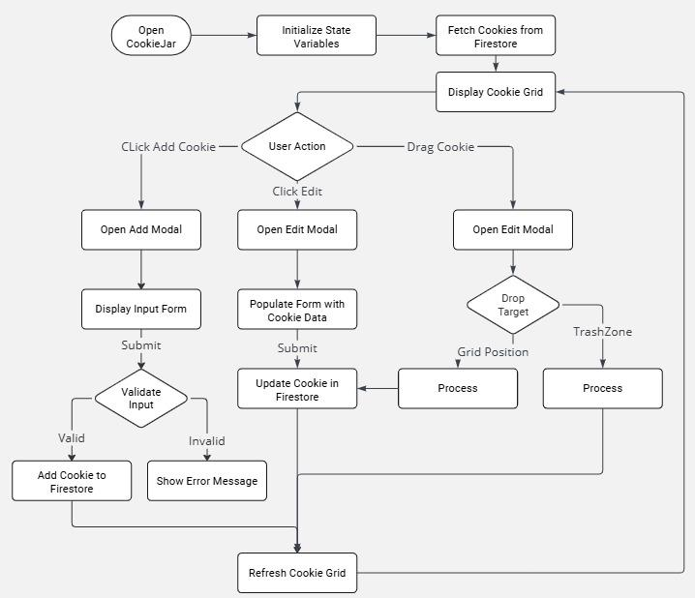

### DoubtTracker

### CuriositySpace

### Notebooks

### ToDoList

### 

### StageManager

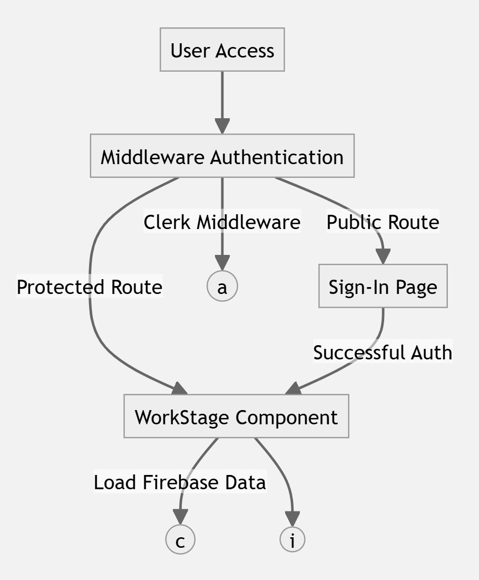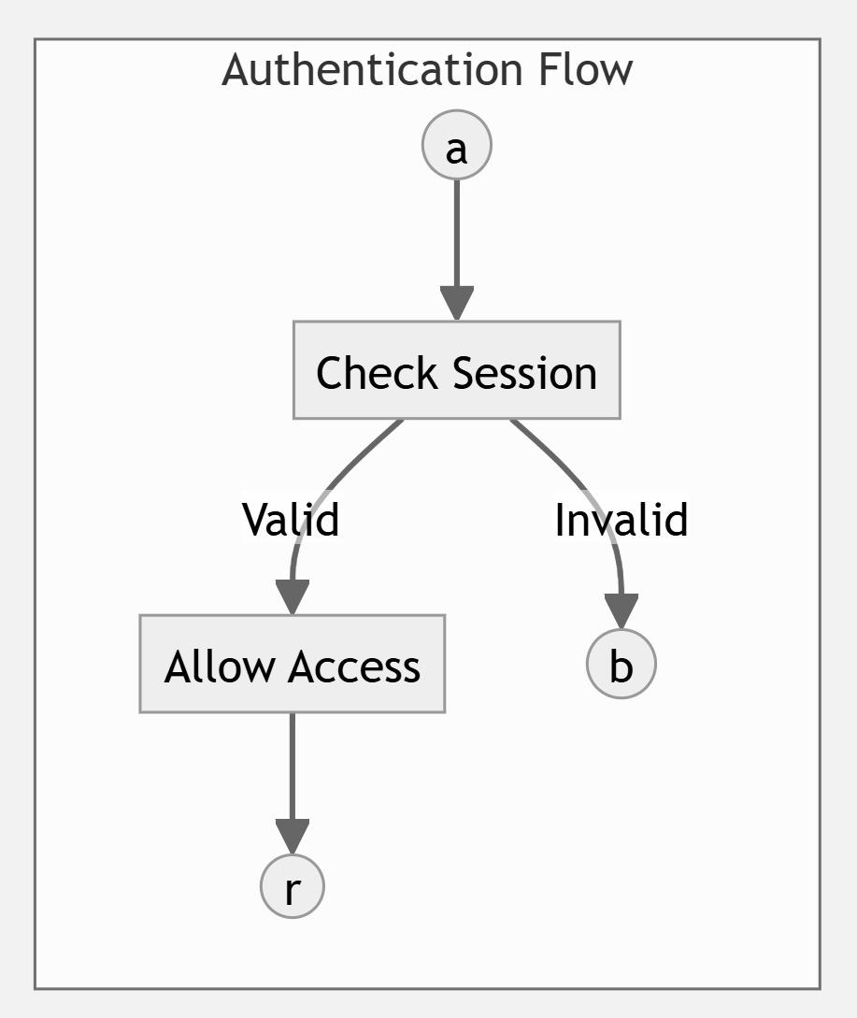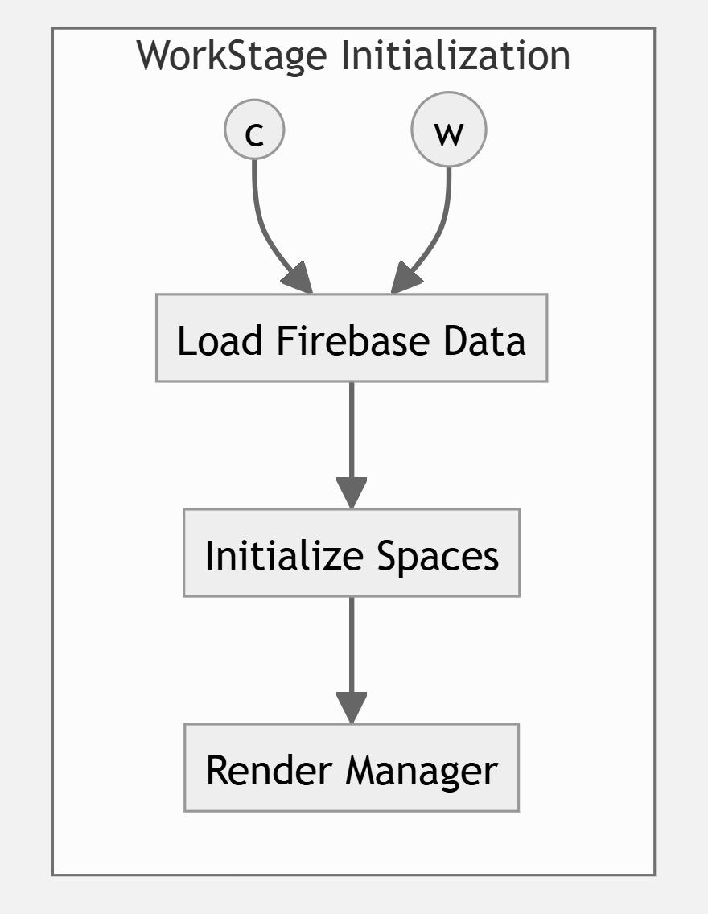

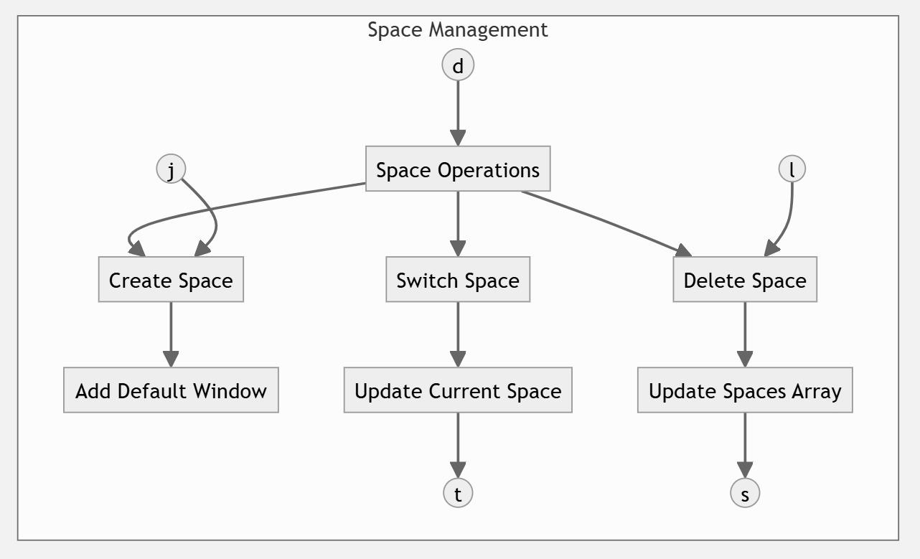

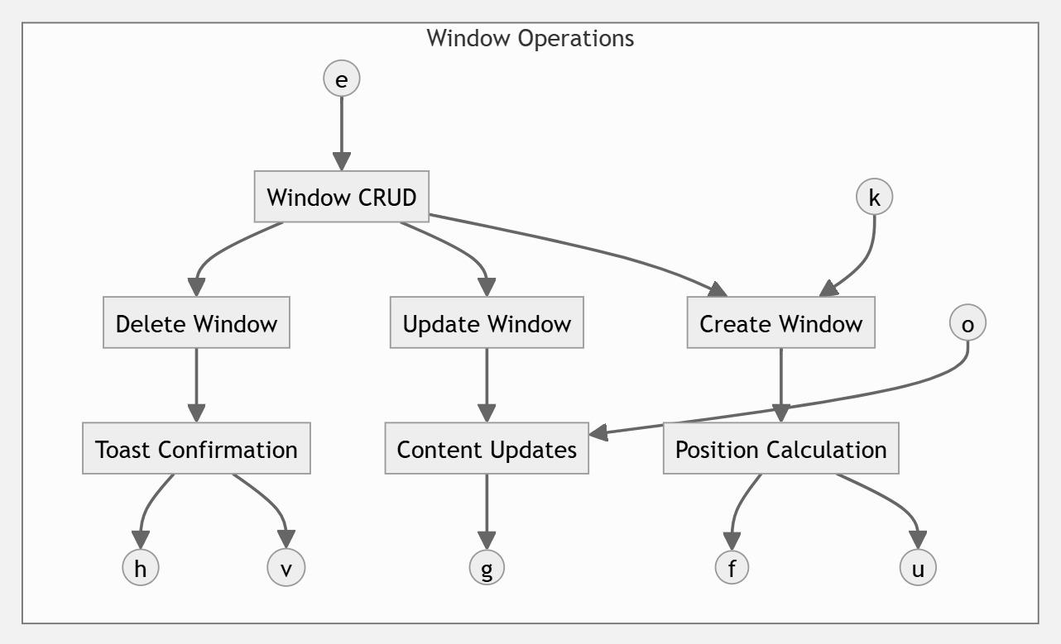

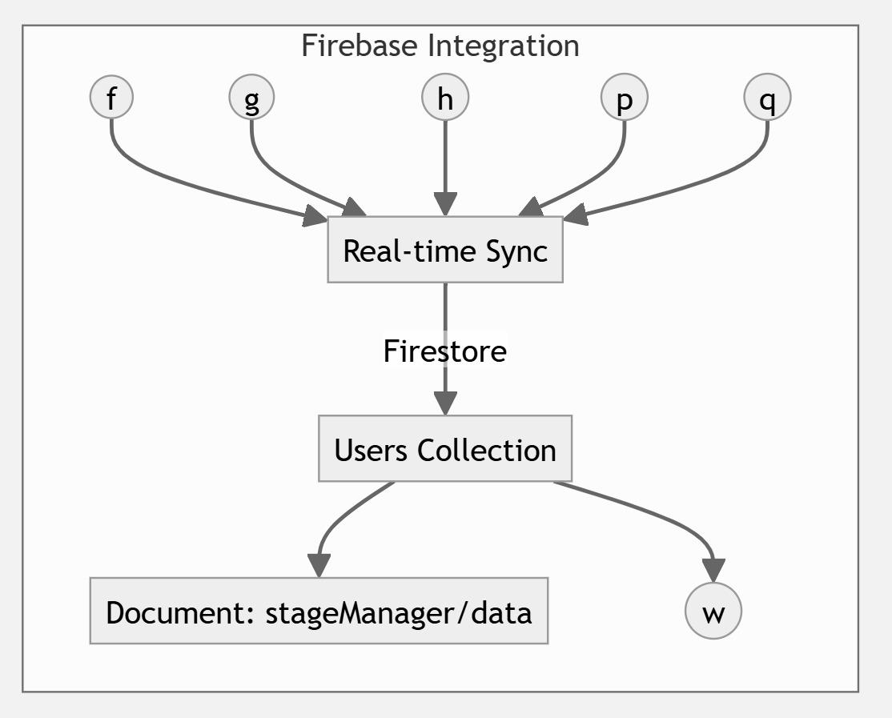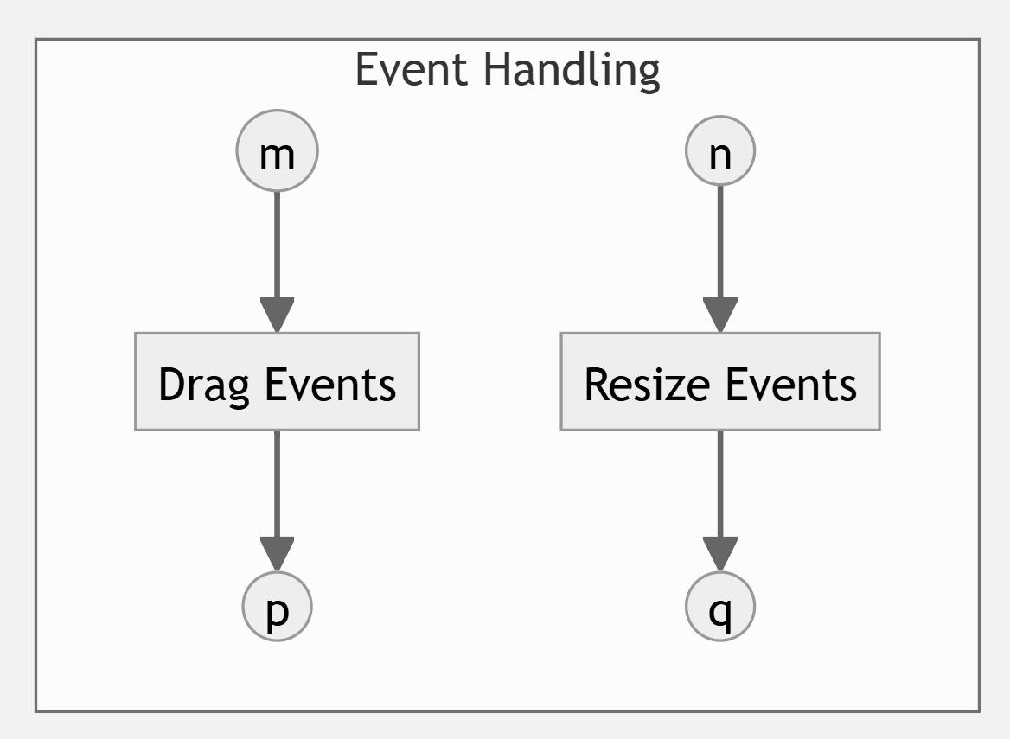

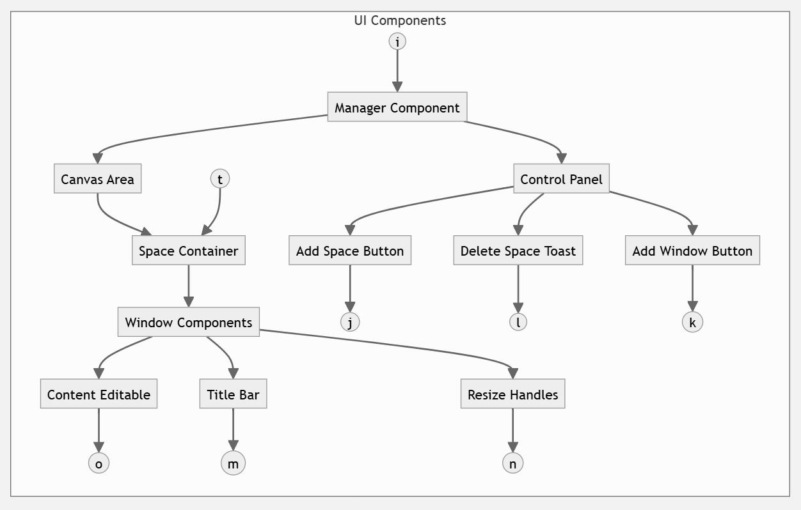

## Modular Abstraction Diagrams

### Overview



### CookieJar

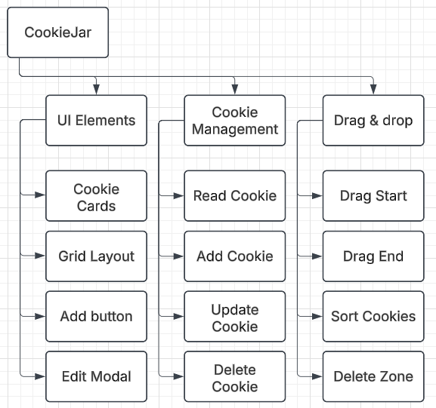

### DoubtTracker

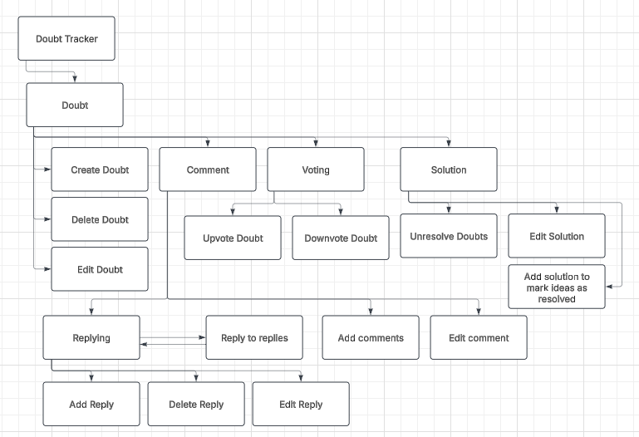

### CuriositySpace

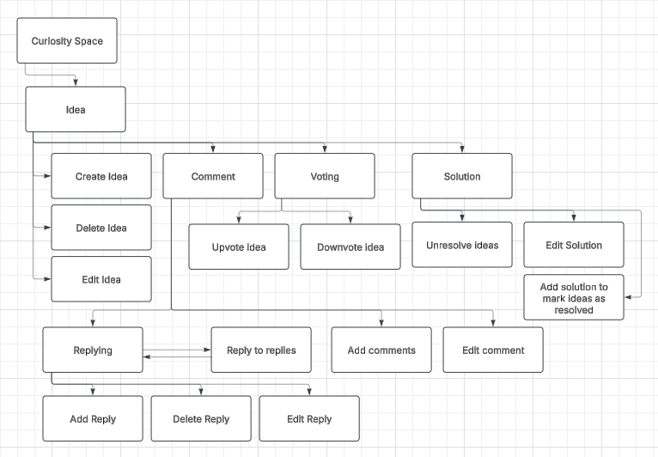

### ToDoList

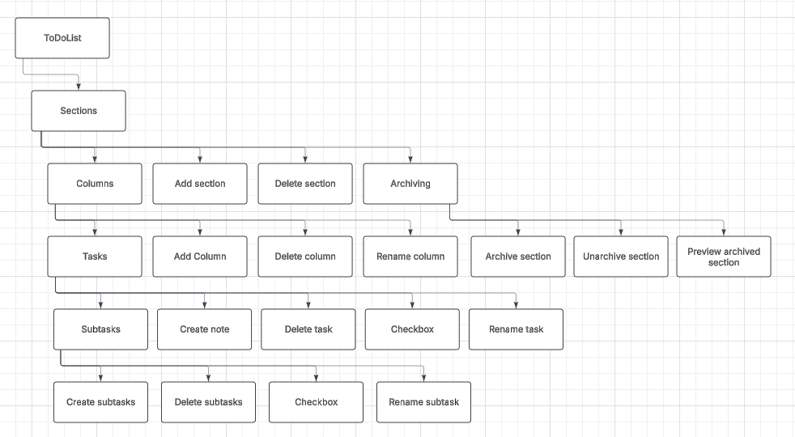

### StageManager

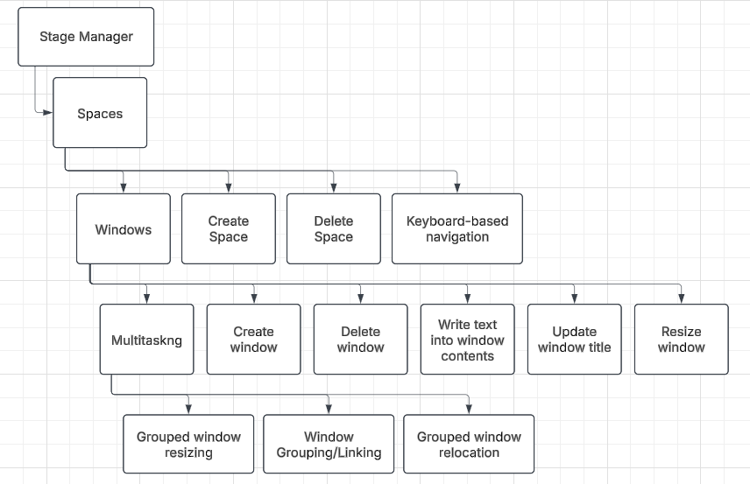

## Screen designs

### Login and registration:

Login



Registration



### Cookie Jar



### DoubtsTracker

DoubtsTracker Open Doubts



DoubtsTracker Resolved Doubts



### 

### CuriositySpace

CuriositySpace Open Ideas

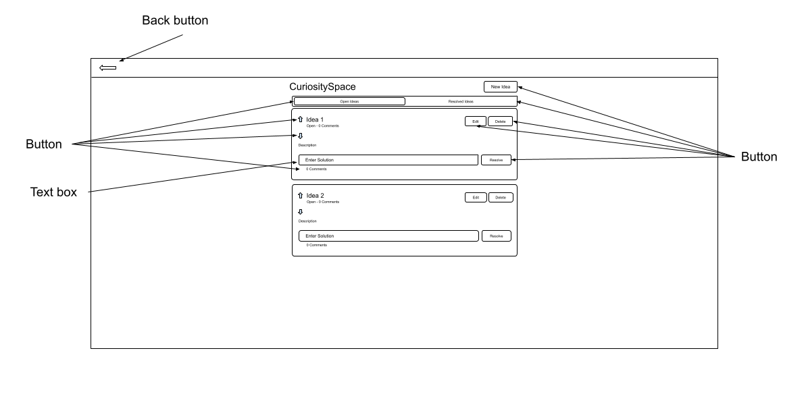

CuriositySpace Resolved Ideas



### Notebooks



Notes



### ToDoList



### Main Page

Workstage view main page



Side-by-Side view main page



Dashboard view main page



## Database (Entity Relationship Diagrams)

### CookieJar

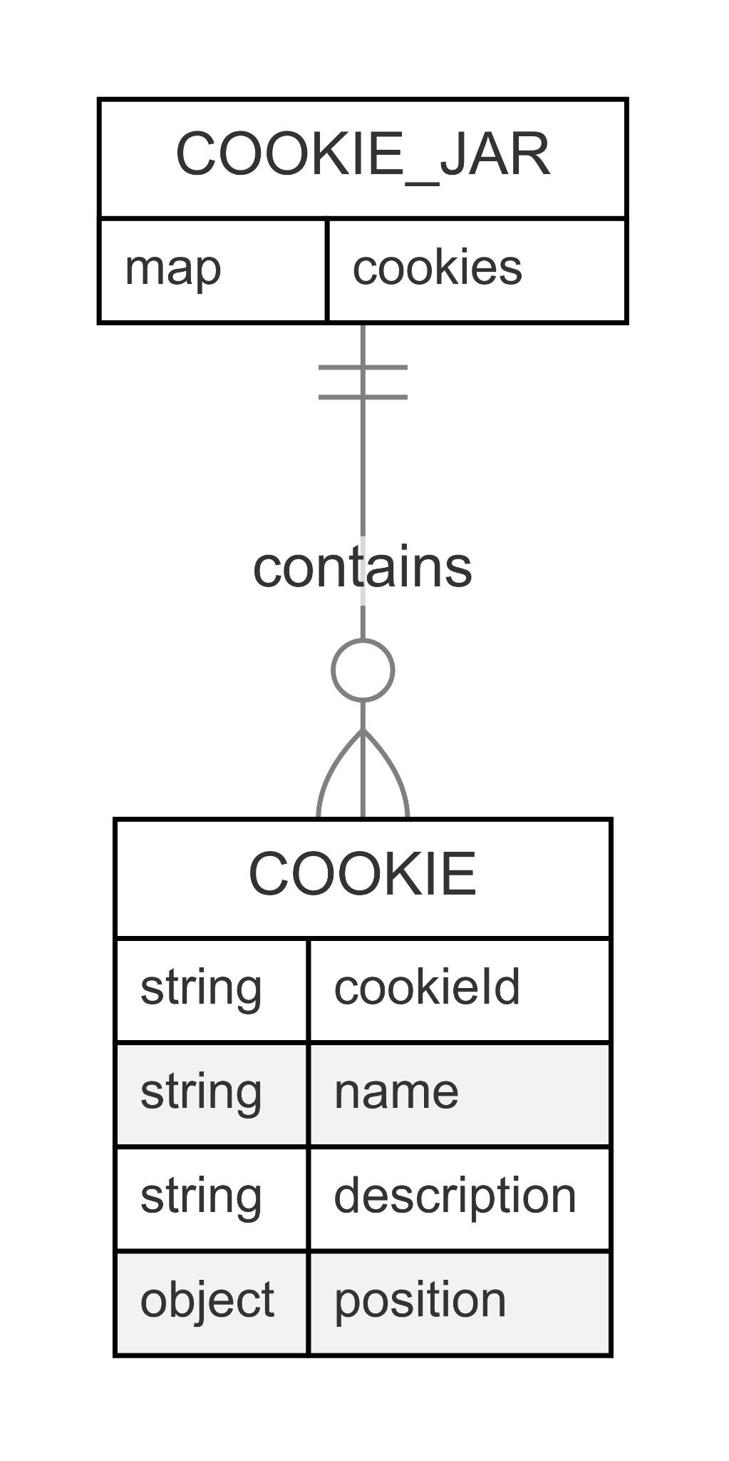

### DoubtTracker and CuriositySpace

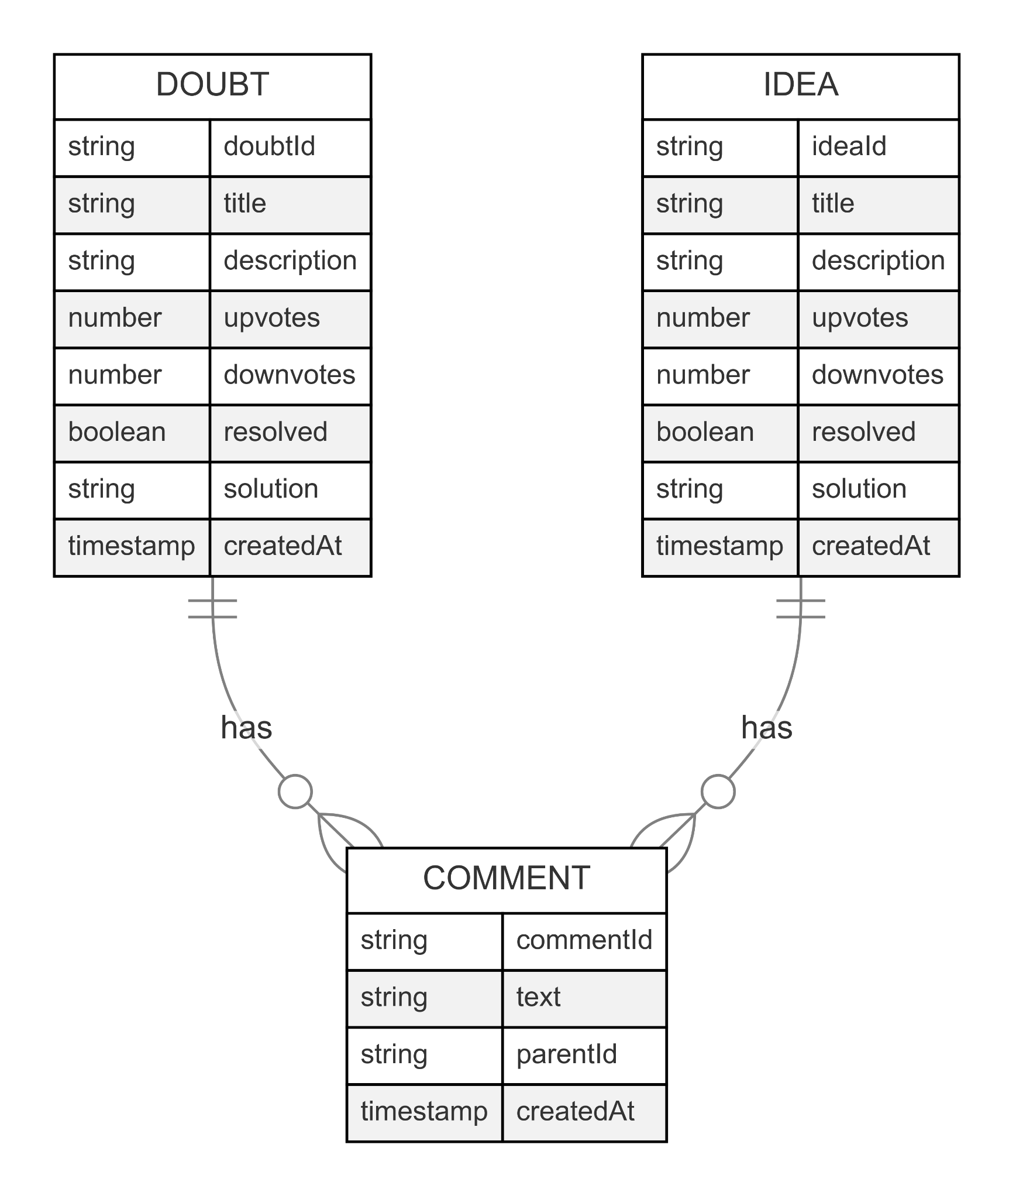

### 

### Notebooks

### ToDoList

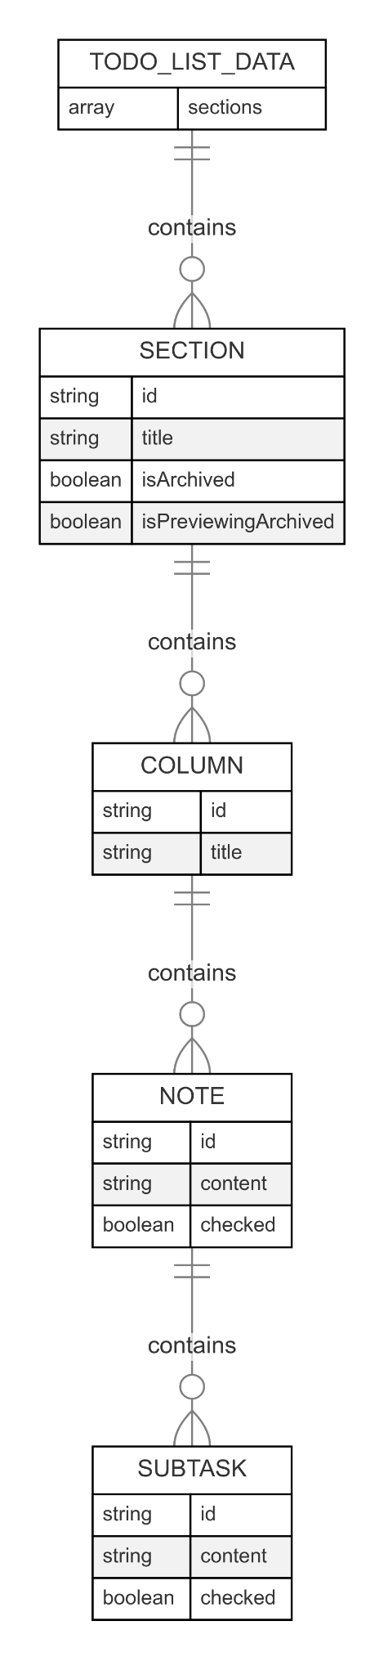

### StageManager

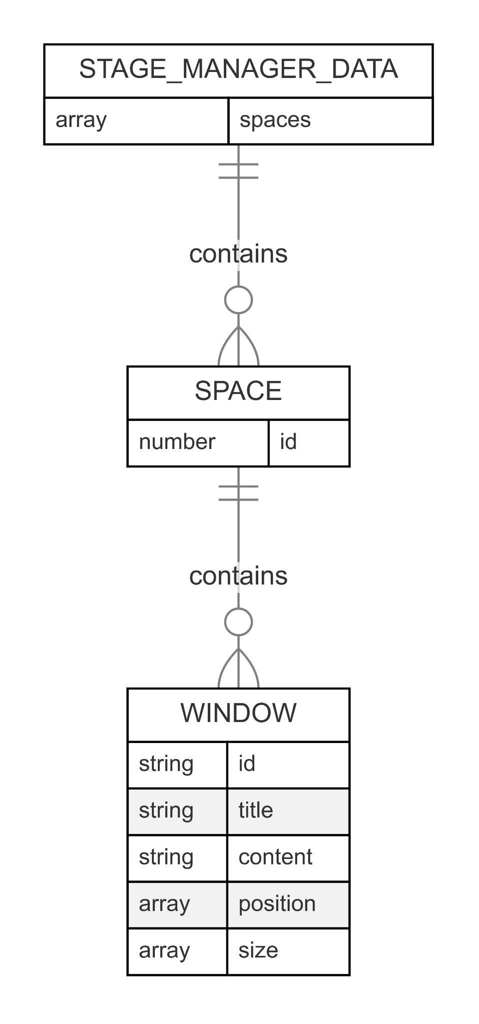

## Pseudocode

### Authentication Logic

#### Handling Protected Route Access (Middleware Flow)

*// Middleware Logic applied to incoming requests*

FUNCTION HandleRequest(request):

*// Define routes that do not require authentication*

DEFINE publicRoutes = ["/sign-in", "/sign-up", "/public-info"]

*// Get the requested path from the request*

requestedPath = GET request.path

*// Check if the requested path is in the list of public routes*

isPublic = CHECK_IF requestedPath IS IN publicRoutes

*// If the route is NOT public, authentication is required*

IF NOT isPublic THEN

*// Check if the user has a valid, active session*

isAuthenticated = CHECK_USER_SESSION()

*// If the user is not authenticated, redirect them to the sign-in page*

IF NOT isAuthenticated THEN

REDIRECT user TO "/sign-in"

STOP *// Prevent further processing of the request*

END IF

END IF

*// If the route is public OR the user is authenticated for a protected route,*

*// allow the request to proceed to the target page/handler.*

PROCEED WITH request

END FUNCTION

#### Processing User Login/Registration (Auth Service Interaction)

*// Login Attempt*

FUNCTION HandleLogin(username, password):

*// Send credentials to Authentication Service for verification*

response = AUTH_SERVICE.verifyCredentials(username, password)

IF response.isSuccessful THEN

*// Create a user session (e.g., set a cookie or token)*

CREATE_USER_SESSION(response.userId)

*// Redirect user to the main application dashboard*

REDIRECT user TO "/dashboard"

ELSE

*// Display an error message to the user (e.g., "Invalid credentials")*

SHOW_ERROR("Invalid username or password.")

END IF

END FUNCTION

*// Registration Attempt*

FUNCTION HandleRegistration(email, password, otherDetails):

*// Check if the email is already registered with the Authentication Service*

emailExists = AUTH_SERVICE.checkEmailExists(email)

IF emailExists THEN

*// Display an error message (e.g., "Email already in use")*

SHOW_ERROR("Email address is already registered.")

ELSE

*// Attempt to create a new user account via the Authentication Service*

response = AUTH_SERVICE.createUser(email, password, otherDetails)

IF response.isSuccessful THEN

*// Automatically log the user in by creating a session*

CREATE_USER_SESSION(response.userId)

*// Redirect user to the main application dashboard or a welcome page*

REDIRECT user TO "/dashboard"

ELSE

*// Display a generic registration error message*

SHOW_ERROR("Registration failed. Please try again.")

END IF

END IF

END FUNCTION

### Cookie Jar

#### Loading and Displaying Cookies

*// When the Cookie Jar module is loaded for a logged-in user*

FUNCTION LoadCookies(userId):

*// Define the expected structure for a single cookie*

DEFINE CookieStructure = { id, name, description, position {x, y} }

*// Access the user's specific data storage area*

userStorage = GET_STORAGE_AREA_FOR_USER(userId)

*// Attempt to retrieve the collection of cookies from storage*

storedCookiesData = userStorage.GET_COLLECTION("cookieJar/cookies")

*// Initialize an empty list to hold the processed cookies*

cookieList = CREATE_EMPTY_LIST()

*// Process the retrieved data*

IF storedCookiesData EXISTS THEN

FOR EACH cookieId, cookieData IN storedCookiesData:

*// Validate cookieData against CookieStructure (optional but good practice)*

*// Create a cookie object including its ID*

cookieObject = CREATE_OBJECT(CookieStructure)

cookieObject.id = cookieId

cookieObject.name = cookieData.name

cookieObject.description = cookieData.description

cookieObject.position = cookieData.position OR {x: 0, y: 0} *// Default position if missing*

ADD cookieObject TO cookieList

END FOR

*// Sort cookies based on their position (y then x) for consistent display*

SORT cookieList BY position.y THEN position.x

END IF

*// Display the sorted cookieList in the user interface grid*

DISPLAY cookieList ON UI_GRID()

END FUNCTION

#### Managing Cookies (Add, Update, Delete)

*// Adding a New Cookie*

FUNCTION AddCookie(userId, name, description):

*// Validate input: Ensure name and description are not empty*

IF name IS EMPTY OR description IS EMPTY THEN

SHOW_ERROR("Name and description cannot be empty.")

RETURN *// Stop processing*

END IF

*// Generate a unique ID for the new cookie*

newCookieId = GENERATE_UNIQUE_ID()

*// Determine initial position (e.g., next available grid spot or default 0,0)*

*// NOTE: Actual position calculation might be complex, simplified here.*

initialPosition = {x: 0, y: 0} *// Placeholder*

*// Create the new cookie data object*

newCookieData = { name: name, description: description, position: initialPosition }

*// Access user's storage and add/update the cookie data*

userStorage = GET_STORAGE_AREA_FOR_USER(userId)

userStorage.SET_ITEM_IN_COLLECTION("cookieJar/cookies", newCookieId, newCookieData)

*// Refresh the UI to show the new cookie*

CALL LoadCookies(userId)

END FUNCTION

*// Updating an Existing Cookie*

FUNCTION UpdateCookie(userId, cookieId, updatedName, updatedDescription):

*// Validate input: Ensure name and description are not empty*

IF updatedName IS EMPTY OR updatedDescription IS EMPTY THEN

SHOW_ERROR("Name and description cannot be empty.")

RETURN

END IF

*// Access user's storage*

userStorage = GET_STORAGE_AREA_FOR_USER(userId)

*// Get the existing cookie data to preserve its position*

existingCookie = userStorage.GET_ITEM_FROM_COLLECTION("cookieJar/cookies", cookieId)

IF NOT existingCookie EXISTS THEN

SHOW_ERROR("Cookie not found.")

RETURN

END IF

*// Create updated cookie data, keeping the original position*

updatedCookieData = { name: updatedName, description: updatedDescription, position: existingCookie.position }

*// Update the cookie data in storage*

userStorage.UPDATE_ITEM_IN_COLLECTION("cookieJar/cookies", cookieId, updatedCookieData)

*// Refresh the UI*

CALL LoadCookies(userId)

END FUNCTION

*// Deleting a Cookie*

FUNCTION DeleteCookie(userId, cookieId):

*// Access user's storage*

userStorage = GET_STORAGE_AREA_FOR_USER(userId)

*// Remove the cookie data associated with the cookieId*

userStorage.DELETE_ITEM_FROM_COLLECTION("cookieJar/cookies", cookieId)

*// Refresh the UI*

CALL LoadCookies(userId)

END FUNCTION

#### Handling Cookie Reordering (Drag & Drop Logic)

*// When a drag-and-drop operation finishes*

FUNCTION HandleCookieDrop(userId, draggedCookieId, targetPositionIndex):

*// 1. Get the current list of cookies (ideally from the UI state before fetching)*

currentCookieList = GET_CURRENT_DISPLAYED_COOKIES()

*// 2. Find the original index of the dragged cookie*

originalIndex = FIND_INDEX_OF_COOKIE(currentCookieList, draggedCookieId)

*// 3. Determine the new index based on the drop target*

newIndex = targetPositionIndex *// This might represent dropping onto another cookie or a grid slot*

*// 4. If indices are valid and different, reorder the list*

IF originalIndex IS VALID AND newIndex IS VALID AND originalIndex != newIndex THEN

*// Create a new list by moving the dragged cookie*

reorderedList = MOVE_ITEM_IN_LIST(currentCookieList, originalIndex, newIndex)

*// 5. Recalculate positions for all cookies in the reordered list*

*// (Assuming a grid layout, e.g., 4 columns)*

DEFINE gridColumns = 4

updatedCookiesWithPositions = CREATE_EMPTY_LIST()

FOR index = 0 TO LENGTH(reorderedList) - 1:

cookie = reorderedList[index]

cookie.position.x = index MOD gridColumns

cookie.position.y = FLOOR(index / gridColumns)

ADD cookie TO updatedCookiesWithPositions

END FOR

*// 6. Persist the updated positions to storage*

userStorage = GET_STORAGE_AREA_FOR_USER(userId)

*// Prepare data for batch update (more efficient)*

batchUpdates = {}

FOR EACH cookie IN updatedCookiesWithPositions:

*// Get only the data needed for storage (excluding ID if ID is the key)*

cookieDataToStore = { name: cookie.name, description: cookie.description, position: cookie.position }

batchUpdates[cookie.id] = cookieDataToStore

END FOR

*// Update the entire 'cookies' collection/document part in one go*

userStorage.UPDATE_COLLECTION("cookieJar/cookies", batchUpdates)

*// 7. Update the UI with the reordered list*

DISPLAY updatedCookiesWithPositions ON UI_GRID()

END IF

END FUNCTION

### Doubt Tracker & Curiosity Space Modules (Combined Logic)

#### Real-time Loading and Displaying Posts/Comments

*// When the Post module (Doubt Tracker or Curiosity Space) is loaded for a user*

FUNCTION LoadPostsRealTime(userId, postType): *// postType could be 'doubts' or 'ideas'*

*// Define the structure for a Post and Comment*

DEFINE PostStructure = { id, title, description, upvotes, downvotes, resolved, solution, createdAt }

DEFINE CommentStructure = { id, text, parentId, createdAt }

*// Access the user's specific storage area for the given post type*

userStorage = GET_STORAGE_AREA_FOR_USER(userId)

postsCollection = userStorage.GET_COLLECTION(postType) *// e.g., 'doubts' or 'ideas'*

*// Define sorting (e.g., newest first)*

query = QUERY(postsCollection).SORT_BY("createdAt", "DESCENDING")

*// Establish a real-time listener on the query*

LISTEN_FOR_UPDATES(query, (updatedSnapshot) => {

postList = CREATE_EMPTY_LIST()

FOR EACH postDoc IN updatedSnapshot.documents:

postData = postDoc.data

*// Validate postData (optional)*

postObject = CREATE_OBJECT(PostStructure)

postObject.id = postDoc.id

*// Assign data from postData to postObject...*

postObject.title = postData.title

postObject.description = postData.description

*// ... (assign other fields)*

ADD postObject TO postList

END FOR

*// Update the UI with the latest list of posts*

DISPLAY postList ON UI()

*// Note: Loading comments typically happens separately when a post is expanded*

*// or could be a sub-listener, simplified here.*

})

*// Store the listener reference to unsubscribe later (e.g., on component unmount)*

STORE_LISTENER_REFERENCE()

END FUNCTION

*// Logic for loading and structuring comments (can be called when a post is expanded)*

FUNCTION LoadCommentsRealTime(userId, postType, postId):

commentsCollection = GET_STORAGE_AREA_FOR_USER(userId).GET_SUBCOLLECTION(postType, postId, "comments")

query = QUERY(commentsCollection).SORT_BY("createdAt", "ASCENDING")

LISTEN_FOR_UPDATES(query, (commentSnapshot) => {

flatCommentList = CREATE_EMPTY_LIST()

FOR EACH commentDoc IN commentSnapshot.documents:

*// Create comment object from commentDoc.data...*

ADD commentObject TO flatCommentList

END FOR

*// Process flatCommentList into a nested structure based on parentId*

nestedComments = BUILD_NESTED_COMMENTS(flatCommentList)

*// Update the UI for the specific post's comment section*

DISPLAY nestedComments FOR postId ON UI()

})

STORE_COMMENT_LISTENER_REFERENCE(postId)

END FUNCTION

#### Managing Posts (Create, Edit, Delete, Resolve/Reopen)

*// Creating a New Post*

FUNCTION CreatePost(userId, postType, title, description):

IF title IS EMPTY OR description IS EMPTY THEN

SHOW_ERROR("Title and description are required.")

RETURN

END IF

newPostData = {

title: title,

description: description,

upvotes: 0,

downvotes: 0,

resolved: FALSE,

solution: "",

createdAt: GET_CURRENT_SERVER_TIMESTAMP()

}

userStorage = GET_STORAGE_AREA_FOR_USER(userId)

postsCollection = userStorage.GET_COLLECTION(postType)

postsCollection.ADD(newPostData)

*// UI updates handled by the real-time listener*

END FUNCTION

*// Editing Post Details*

FUNCTION EditPost(userId, postType, postId, newTitle, newDescription):

IF newTitle IS EMPTY OR newDescription IS EMPTY THEN

SHOW_ERROR("Title and description are required.")

RETURN

END IF

updates = { title: newTitle, description: newDescription }

userStorage = GET_STORAGE_AREA_FOR_USER(userId)

postRef = userStorage.GET_DOCUMENT_REFERENCE(postType, postId)

postRef.UPDATE(updates)

*// UI updates handled by the real-time listener*

END FUNCTION

*// Deleting a Post*

FUNCTION DeletePost(userId, postType, postId):

*// Optional: Add confirmation dialog*

userStorage = GET_STORAGE_AREA_FOR_USER(userId)

postRef = userStorage.GET_DOCUMENT_REFERENCE(postType, postId)

*// Need to also delete subcollections like comments if they exist*

DELETE_SUBCOLLECTION(postRef, "comments") *// Simplified representation*

postRef.DELETE()

*// UI updates handled by the real-time listener*

END FUNCTION

*// Resolving a Post*

FUNCTION ResolvePost(userId, postType, postId, solutionText):

IF solutionText IS EMPTY THEN

SHOW_ERROR("Solution cannot be empty.")

RETURN

END IF

updates = { resolved: TRUE, solution: solutionText }

userStorage = GET_STORAGE_AREA_FOR_USER(userId)

postRef = userStorage.GET_DOCUMENT_REFERENCE(postType, postId)

postRef.UPDATE(updates)

*// UI updates handled by the real-time listener*

END FUNCTION

*// Reopening a Post*

FUNCTION ReopenPost(userId, postType, postId):

updates = { resolved: FALSE, solution: "" } *// Clear solution on reopen*

userStorage = GET_STORAGE_AREA_FOR_USER(userId)

postRef = userStorage.GET_DOCUMENT_REFERENCE(postType, postId)

postRef.UPDATE(updates)

*// UI updates handled by the real-time listener*

END FUNCTION

#### Handling Votes and Comments

*// Handling Votes*

FUNCTION UpdateVote(userId, postType, postId, voteType): *// voteType is 'upvote' or 'downvote'*

userStorage = GET_STORAGE_AREA_FOR_USER(userId)

postRef = userStorage.GET_DOCUMENT_REFERENCE(postType, postId)

IF voteType == 'upvote' THEN

*// Use atomic increment operation*

postRef.UPDATE({ upvotes: INCREMENT(1) })

ELSE IF voteType == 'downvote' THEN

postRef.UPDATE({ downvotes: INCREMENT(1) })

END IF

*// UI updates handled by the real-time listener*

END FUNCTION

*// Adding a Comment/Reply*

FUNCTION AddComment(userId, postType, postId, commentText, parentCommentId = NULL):

IF commentText IS EMPTY THEN

SHOW_ERROR("Comment cannot be empty.")

RETURN

END IF

newCommentData = {

text: commentText,

parentId: parentCommentId, *// Store parent ID for replies*

createdAt: GET_CURRENT_SERVER_TIMESTAMP()

}

userStorage = GET_STORAGE_AREA_FOR_USER(userId)

commentsCollection = userStorage.GET_SUBCOLLECTION(postType, postId, "comments")

commentsCollection.ADD(newCommentData)

*// UI updates handled by the comment real-time listener*

END FUNCTION

*// Editing a Comment*

FUNCTION EditComment(userId, postType, postId, commentId, newText):

IF newText IS EMPTY THEN

SHOW_ERROR("Comment cannot be empty.")

RETURN

END IF

userStorage = GET_STORAGE_AREA_FOR_USER(userId)

commentRef = userStorage.GET_DOCUMENT_REFERENCE(postType, postId, "comments", commentId)

commentRef.UPDATE({ text: newText })

*// UI updates handled by the comment real-time listener*

END FUNCTION

*// Deleting a Comment*

FUNCTION DeleteComment(userId, postType, postId, commentId):

*// Need to handle deleting replies recursively if deleting a parent comment*

*// Simplified here:*

userStorage = GET_STORAGE_AREA_FOR_USER(userId)

commentRef = userStorage.GET_DOCUMENT_REFERENCE(postType, postId, "comments", commentId)

*// Add logic here to find and delete replies first if necessary*

commentRef.DELETE()

*// UI updates handled by the comment real-time listener*

END FUNCTION

### Notebooks

#### Notebook Lifecycle (Create, Load List, Delete)

*// Loading the List of Notebooks (e.g., for the Notebook Manager view)*

FUNCTION LoadNotebookList(userId):

DEFINE NotebookMetaStructure = { id, title, description, updatedAt }

userStorage = GET_STORAGE_AREA_FOR_USER(userId)

notebooksCollection = userStorage.GET_COLLECTION("notebooks")

*// Retrieve all documents from the notebooks collection*

notebookDocs = notebooksCollection.GET_ALL_DOCUMENTS()

notebookList = CREATE_EMPTY_LIST()

FOR EACH doc IN notebookDocs:

data = doc.data

*// Basic validation*

IF data.title EXISTS THEN

notebookMeta = CREATE_OBJECT(NotebookMetaStructure)

notebookMeta.id = doc.id

notebookMeta.title = data.title

notebookMeta.description = data.description OR ""

notebookMeta.updatedAt = data.updatedAt *// Assuming timestamp exists*

ADD notebookMeta TO notebookList

END IF

END FOR

*// Sort notebooks, e.g., by last updated time*

SORT notebookList BY updatedAt DESCENDING

*// Display the list of notebooks in the UI*

DISPLAY notebookList ON UI()

END FUNCTION

*// Creating a New Notebook*

FUNCTION CreateNotebook(userId, title, description = ""):

IF title IS EMPTY THEN

SHOW_ERROR("Notebook title cannot be empty.")

RETURN NULL *// Indicate failure*

END IF

newNotebookData = {

title: title,

description: description,

userId: userId,

sections: [], *// Initialize with empty sections array*

createdAt: GET_CURRENT_SERVER_TIMESTAMP(),

updatedAt: GET_CURRENT_SERVER_TIMESTAMP()

}

userStorage = GET_STORAGE_AREA_FOR_USER(userId)

notebooksCollection = userStorage.GET_COLLECTION("notebooks")

*// Add the new notebook document, letting the storage generate the ID*

newNotebookRef = notebooksCollection.ADD(newNotebookData)

*// Return the ID of the newly created notebook*

RETURN newNotebookRef.id

END FUNCTION

*// Deleting a Notebook*

FUNCTION DeleteNotebook(userId, notebookId):

*// Optional: Add confirmation dialog*

userStorage = GET_STORAGE_AREA_FOR_USER(userId)

notebookRef = userStorage.GET_DOCUMENT_REFERENCE("notebooks", notebookId)

*// Delete the notebook document*

notebookRef.DELETE()

*// Refresh the notebook list in the UI*

CALL LoadNotebookList(userId)

END FUNCTION

#### Notebook Content Management (Loading/Saving Sections, Columns, Notes)

*// Loading Content of a Specific Notebook (e.g., when opening it)*

FUNCTION LoadNotebookContent(userId, notebookId):

DEFINE SectionStructure = { id, title, columns }

DEFINE ColumnStructure = { id, title, notes }

DEFINE NoteStructure = { id, content }

userStorage = GET_STORAGE_AREA_FOR_USER(userId)

notebookRef = userStorage.GET_DOCUMENT_REFERENCE("notebooks", notebookId)

notebookDoc = notebookRef.GET_DOCUMENT()

IF notebookDoc EXISTS THEN

notebookData = notebookDoc.data

*// Store the loaded sections in the application's state*

*// This assumes 'sections' is an array directly within the notebook document*

*// Perform necessary validation/structuring*

loadedSections = VALIDATE_AND_STRUCTURE(notebookData.sections, SectionStructure, ColumnStructure, NoteStructure)

SET_APPLICATION_STATE("currentNotebookSections", loadedSections)

*// Display the loaded content in the notebook UI*

DISPLAY loadedSections ON NOTEBOOK_UI()

ELSE

SHOW_ERROR("Notebook not found.")

*// Potentially redirect user back*

END IF

END FUNCTION

*// Saving Notebook Content (Called by Debounced Sync)*

FUNCTION SaveNotebookContent(userId, notebookId, currentSectionsState):

userStorage = GET_STORAGE_AREA_FOR_USER(userId)

notebookRef = userStorage.GET_DOCUMENT_REFERENCE("notebooks", notebookId)

*// Prepare data for update, only including sections and the updated timestamp*

updateData = {

sections: currentSectionsState, *// The current state from the UI/application*

updatedAt: GET_CURRENT_SERVER_TIMESTAMP()

}

*// Update the notebook document using MERGE to avoid overwriting other fields*

notebookRef.UPDATE(updateData, { merge: TRUE })

END FUNCTION

*// Adding a New Section to the Current Notebook*

FUNCTION AddSection(currentSectionsState):

newSection = {

id: GENERATE_UNIQUE_ID(),

title: "New Section",

columns: [ { id: GENERATE_UNIQUE_ID(), title: "New Column", notes: [] } ] *// Start with one column*

}

newState = ADD newSection TO currentSectionsState

SET_APPLICATION_STATE("currentNotebookSections", newState)

*// Saving happens via debounced sync*

END FUNCTION

*// Adding a New Column to a Section*

FUNCTION AddColumn(currentSectionsState, targetSectionId):

newState = MAP currentSectionsState WHERE section.id == targetSectionId:

ADD { id: GENERATE_UNIQUE_ID(), title: "New Column", notes: [] } TO section.columns

END MAP

SET_APPLICATION_STATE("currentNotebookSections", newState)

*// Saving happens via debounced sync*

END FUNCTION

*// Adding a New Note to a Column*

FUNCTION AddNote(currentSectionsState, targetSectionId, targetColumnId):

newState = MAP currentSectionsState WHERE section.id == targetSectionId:

MAP section.columns WHERE column.id == targetColumnId:

ADD { id: GENERATE_UNIQUE_ID(), content: "New Note" } TO column.notes

END MAP

END MAP

SET_APPLICATION_STATE("currentNotebookSections", newState)

*// Saving happens via debounced sync*

END FUNCTION

*// Updating Note Content (e.g., after inline editing)*

FUNCTION UpdateNoteContent(currentSectionsState, sectionId, columnId, noteId, newContent):

newState = MAP currentSectionsState WHERE section.id == sectionId:

MAP section.columns WHERE column.id == columnId:

MAP column.notes WHERE note.id == noteId:

note.content = newContent

END MAP

END MAP

END MAP

SET_APPLICATION_STATE("currentNotebookSections", newState)

*// Saving happens via debounced sync*

END FUNCTION

*// Deleting Sections/Columns/Notes (Similar pattern, update state, sync saves)*

FUNCTION DeleteItem(currentSectionsState, type, sectionId, columnId = NULL, noteId = NULL):

*// Logic to find and remove the item (section, column, or note) based on type and IDs*

*// ... find the item and remove it from the nested structure ...*

newState = REMOVE_ITEM(currentSectionsState, type, sectionId, columnId, noteId)

SET_APPLICATION_STATE("currentNotebookSections", newState)

*// Saving happens via debounced sync*

*// Optional: Show confirmation/undo toast*

END FUNCTION

#### Handling Note Reordering/Movement (Drag & Drop)

*// When a drag-and-drop operation finishes for a Note*

FUNCTION HandleNoteDrop(currentSectionsState, draggedNoteId, sourceLocation, targetLocation):

*// sourceLocation = { sectionId, columnId }*

*// targetLocation = { sectionId, columnId, targetNoteId (optional, for position) }*

*// 1. Find and remove the note from the source location in a temporary state*

tempState = REMOVE_NOTE(currentSectionsState, draggedNoteId, sourceLocation)

IF noteNotFound THEN RETURN *// Safety check*

*// 2. Find the target index in the target column*

targetIndex = DETERMINE_TARGET_INDEX(tempState, targetLocation)

*// 3. Insert the dragged note into the target location at the target index*

newState = INSERT_NOTE_AT_INDEX(tempState, draggedNote, targetLocation, targetIndex)

*// 4. Update the application state*

SET_APPLICATION_STATE("currentNotebookSections", newState)

*// Saving happens via debounced sync*

END FUNCTION

#### Debounced Data Synchronization

*// Global or Module-level variables*

DEFINE debounceTimer = NULL

DEFINE debounceDelay = 1000 *// milliseconds (e.g., 1 second)*

*// Function called whenever the notebook content state changes*

FUNCTION OnContentChange(userId, notebookId, currentSectionsState):

*// Clear any existing timer to reset the debounce period*

CLEAR_TIMER(debounceTimer)

*// Set a new timer*

debounceTimer = SET_TIMER(() => {

CALL SaveNotebookContent(userId, notebookId, currentSectionsState)

}, debounceDelay)

END FUNCTION

*// NOTE: Every function that modifies 'currentSectionsState' (AddSection, AddColumn, AddNote, UpdateNoteContent, DeleteItem, HandleNoteDrop, etc.)*

*// should call OnContentChange AFTER updating the state.*

### ToDo List

#### Loading and Saving ToDo List Structure

*// When the ToDo List module is loaded for a user*

FUNCTION LoadToDoList(userId):

*// Define expected data structures*

DEFINE SubtaskStructure = { id, content, checked }

DEFINE TaskStructure = { id, content, checked, subtasks: LIST OF SubtaskStructure }

DEFINE ColumnStructure = { id, title, notes: LIST OF TaskStructure }

DEFINE SectionStructure = { id, title, columns: LIST OF ColumnStructure, isArchived: BOOLEAN }

userStorage = GET_STORAGE_AREA_FOR_USER(userId)

*// Specific document path for ToDo list data*

todoListRef = userStorage.GET_DOCUMENT_REFERENCE("todoList", "data")

todoListDoc = todoListRef.GET_DOCUMENT()

IF todoListDoc EXISTS THEN

todoData = todoListDoc.data

*// Extract sections, handling potential missing data and ensuring structure*

loadedSections = VALIDATE_AND_STRUCTURE(todoData.sections, SectionStructure, ...) *// Similar validation as notebooks*

*// Separate archived and active sections based on isArchived flag*

activeSections = FILTER loadedSections WHERE section.isArchived IS FALSE

archivedSections = FILTER loadedSections WHERE section.isArchived IS TRUE

*// Store in application state*

SET_APPLICATION_STATE("currentToDoSections", activeSections)

SET_APPLICATION_STATE("archivedToDoSections", archivedSections)

*// Display active sections in the main UI*

DISPLAY activeSections ON TODO_UI()

ELSE

*// If no data exists, initialize with empty state and save it*

initialState = { sections: [] }

todoListRef.SET(initialState)

SET_APPLICATION_STATE("currentToDoSections", [])

SET_APPLICATION_STATE("archivedToDoSections", [])

DISPLAY [] ON TODO_UI()

END IF

END FUNCTION

*// Saving ToDo List Data (Called by Debounced Sync)*

FUNCTION SaveToDoList(userId, currentActiveSections, currentArchivedSections):

userStorage = GET_STORAGE_AREA_FOR_USER(userId)

todoListRef = userStorage.GET_DOCUMENT_REFERENCE("todoList", "data")

*// Combine active and archived sections back into one list for saving*

allSections = COMBINE(currentActiveSections, currentArchivedSections)

updateData = {

sections: allSections,

lastUpdated: GET_CURRENT_SERVER_TIMESTAMP()

}

*// Overwrite the document with the combined, current state*

todoListRef.SET(updateData)

END FUNCTION

*// Debounced Synchronization (Same logic as Notebooks Module 5.4)*

*// Uses SaveToDoList as the function to call after the delay.*

*// FUNCTION OnToDoContentChange(userId, activeSections, archivedSections): ... calls SaveToDoList ...*

#### Managing List Items (Sections, Columns, Tasks, Subtasks - Add, Edit, Delete)

*// Add Section, Add Column, Add Task (Note), Add Subtask*

*// These follow the same pattern as the Notebooks module (5.2):*

*// 1. Create new item object with unique ID and default values.*

*// 2. Update the application state (currentToDoSections).*

*// 3. Trigger the debounced save via OnToDoContentChange.*

FUNCTION AddToDoItem(state, type, parentId1 = NULL, parentId2 = NULL): *// parentIds specify section/column/task*

*// ... create newItem based on type ...*

newState = ADD newItem TO HIERARCHY(state, parentId1, parentId2)

SET_APPLICATION_STATE("currentToDoSections", newState)

CALL OnToDoContentChange(...)

END FUNCTION

*// Editing Titles/Content (Sections, Columns, Tasks, Subtasks)*

*// Similar to Notebooks (5.2 UpdateNoteContent):*

*// 1. Find the item in the application state by IDs.*

*// 2. Update its title or content property.*

*// 3. Trigger the debounced save.*

FUNCTION UpdateToDoItem(state, type, ids, newContentOrTitle):

newState = MAP state TO FIND_AND_UPDATE_ITEM(ids, newContentOrTitle)

SET_APPLICATION_STATE("currentToDoSections", newState)

CALL OnToDoContentChange(...)

END FUNCTION

*// Deleting Items (Sections, Columns, Tasks, Subtasks)*

FUNCTION DeleteToDoItemWithUndo(state, type, ids): *// ids = {sectionId, columnId, taskId, subtaskId}*

*// 1. Find the item and its parent hierarchy to facilitate undo*

itemToDelete = FIND_ITEM(state, ids)

parentContext = FIND_PARENT_CONTEXT(state, ids)

originalIndex = FIND_ITEM_INDEX(parentContext, itemToDelete)

IF itemNotFound THEN RETURN

*// 2. Update the state by removing the item*

newState = REMOVE_ITEM(state, ids)

SET_APPLICATION_STATE("currentToDoSections", newState)

CALL OnToDoContentChange(...) *// Trigger save immediately or debounced*

*// 3. Show a Toast notification with an Undo action*

SHOW_TOAST({

message: type + " deleted.",

action: "Undo",

onUndo: () => {

*// Re-insert the item at its original position*

restoredState = INSERT_ITEM_AT_INDEX(newState, itemToDelete, parentContext, originalIndex)

SET_APPLICATION_STATE("currentToDoSections", restoredState)

CALL OnToDoContentChange(...) *// Trigger save for undo*

}

})

END FUNCTION

#### Task State Management (Checkbox Toggle, Archiving)

*// Toggling Checkbox for Task or Subtask*

FUNCTION ToggleCompletion(state, ids): *// ids = {sectionId, columnId, taskId, subtaskId (optional)}*

newState = MAP state TO FIND_ITEM(ids):

item.checked = NOT item.checked

END MAP

SET_APPLICATION_STATE("currentToDoSections", newState)

CALL OnToDoContentChange(...)

END FUNCTION

*// Archiving a Section*

FUNCTION ArchiveSection(activeSectionsState, archivedSectionsState, sectionId):

sectionToArchive = FIND_ITEM(activeSectionsState, {sectionId: sectionId})

IF sectionNotFound THEN RETURN

*// Remove from active, add to archived with flag set*

newActiveState = REMOVE_ITEM(activeSectionsState, {sectionId: sectionId})

sectionToArchive.isArchived = TRUE

newArchivedState = ADD sectionToArchive TO archivedSectionsState

SET_APPLICATION_STATE("currentToDoSections", newActiveState)

SET_APPLICATION_STATE("archivedToDoSections", newArchivedState)

CALL OnToDoContentChange(...)

END FUNCTION

*// Unarchiving a Section*

FUNCTION UnarchiveSection(activeSectionsState, archivedSectionsState, sectionId):

sectionToUnarchive = FIND_ITEM(archivedSectionsState, {sectionId: sectionId})

IF sectionNotFound THEN RETURN

*// Remove from archived, add to active with flag unset*

newArchivedState = REMOVE_ITEM(archivedSectionsState, {sectionId: sectionId})

sectionToUnarchive.isArchived = FALSE

newActiveState = ADD sectionToUnarchive TO activeSectionsState

SET_APPLICATION_STATE("currentToDoSections", newActiveState)

SET_APPLICATION_STATE("archivedToDoSections", newArchivedState)

CALL OnToDoContentChange(...)

END FUNCTION

#### Handling Item Reordering/Movement (Drag & Drop Logic)

*// Handles Column, Task, and Subtask drag/drop end events*

FUNCTION HandleToDoDrop(currentState, draggedItemType, draggedItemId, sourceLocation, targetLocation):

*// sourceLocation = {sectionId, columnId, parentTaskId (for subtask)}*

*// targetLocation = {sectionId, columnId, parentTaskId (for subtask), targetItemId (optional)}*

*// --- Logic similar to Notebooks (5.3) ---*

*// 1. Identify the dragged item data based on ID and type*

draggedItem = FIND_ITEM(currentState, sourceLocation, draggedItemId)

IF itemNotFound THEN RETURN

*// 2. Create temporary state removing item from source*

tempState = REMOVE_ITEM(currentState, sourceLocation, draggedItemId)

*// 3. Determine the target index based on targetLocation (where it was dropped)*

targetIndex = DETERMINE_TARGET_INDEX(tempState, targetLocation)

*// 4. Insert the item into the target location at the calculated index*

*// (Handles moves between columns/tasks or reordering within the same parent)*

newState = INSERT_ITEM_AT_INDEX(tempState, draggedItem, targetLocation, targetIndex)

*// 5. Update application state*

SET_APPLICATION_STATE("currentToDoSections", newState)

CALL OnToDoContentChange(...) *// Trigger debounced save*

END FUNCTION

### Stage Manager (WorkStage)

#### Loading and Persisting Workspace Layout

*// When the Stage Manager module is loaded for a user*

FUNCTION LoadStageLayout(userId):

*// Define expected structures*

DEFINE WindowStructure = { id, title, content, position: [x, y], size: [width, height] }

DEFINE SpaceStructure = { id: number, windows: LIST OF WindowStructure } *// Use number ID for easy indexing if needed*

userStorage = GET_STORAGE_AREA_FOR_USER(userId)

*// Specific document for Stage Manager data*

stageDataRef = userStorage.GET_DOCUMENT_REFERENCE("stageManager", "data")

stageDoc = stageDataRef.GET_DOCUMENT()

IF stageDoc EXISTS THEN

stageData = stageDoc.data

*// Validate and structure the loaded spaces and windows*

loadedSpaces = VALIDATE_AND_STRUCTURE(stageData.spaces, SpaceStructure, WindowStructure)

*// Ensure at least one space exists, create default if none*

IF LENGTH(loadedSpaces) == 0 THEN

defaultSpace = { id: 0, windows: [ { id: GENERATE_UNIQUE_ID(), title: "New Document", content: "", position: [100, 100], size: [400, 300] } ] }

loadedSpaces = [defaultSpace]

*// Persist the default state immediately*

CALL SaveStageLayout(userId, loadedSpaces)

END IF

*// Set the initial state*

SET_APPLICATION_STATE("stageSpaces", loadedSpaces)

SET_APPLICATION_STATE("currentStageSpaceId", loadedSpaces[0].id) *// Default to the first space*

DISPLAY loadedSpaces[0] ON STAGE_UI() *// Display the first space*

ELSE

*// Create and save the default initial state if no data exists*

defaultSpace = { id: 0, windows: [ { id: GENERATE_UNIQUE_ID(), title: "New Document", content: "", position: [100, 100], size: [400, 300] } ] }

initialState = { spaces: [defaultSpace] }

stageDataRef.SET(initialState)

SET_APPLICATION_STATE("stageSpaces", [defaultSpace])

SET_APPLICATION_STATE("currentStageSpaceId", 0)

DISPLAY defaultSpace ON STAGE_UI()

END IF

END FUNCTION

*// Saving the entire Stage Layout (Called whenever 'stageSpaces' state changes)*

*// NOTE: Unlike ToDo/Notebooks, Stage Manager might benefit from saving the *entire* layout*

*// on change rather than debouncing, as layout changes are discrete events. Or debounce lightly.*

FUNCTION SaveStageLayout(userId, currentSpacesState):

userStorage = GET_STORAGE_AREA_FOR_USER(userId)

stageDataRef = userStorage.GET_DOCUMENT_REFERENCE("stageManager", "data")

updateData = {

spaces: currentSpacesState

*// lastUpdated: GET_CURRENT_SERVER_TIMESTAMP() // Optional timestamp*

}

*// Overwrite the document with the current layout state*

stageDataRef.SET(updateData)

END FUNCTION

#### Space Management (Create, Switch, Delete)

*// Creating a New Space*

FUNCTION CreateSpace(userId, currentSpacesState):

*// Determine the next available ID (e.g., max current ID + 1)*

nextId = MAX(currentSpacesState.map(s => s.id)) + 1

*// Create a default window for the new space*

defaultWindow = {

id: GENERATE_UNIQUE_ID(),

title: "New Document",

content: "",

position: [100, 100], *// Default position*

size: [400, 300] *// Default size*

}

newSpace = { id: nextId, windows: [defaultWindow] }

*// Update state and trigger save*

newState = ADD newSpace TO currentSpacesState

SET_APPLICATION_STATE("stageSpaces", newState)

*// Switch to the newly created space*

SET_APPLICATION_STATE("currentStageSpaceId", nextId)

CALL SaveStageLayout(userId, newState)

*// Update UI to show the new space*

DISPLAY newSpace ON STAGE_UI()

END FUNCTION

*// Switching Between Spaces*

FUNCTION SwitchSpace(targetSpaceId):

*// Validate targetSpaceId exists in currentSpacesState (optional)*

SET_APPLICATION_STATE("currentStageSpaceId", targetSpaceId)

*// Update UI to display the windows of the targetSpaceId*

targetSpace = FIND_SPACE_BY_ID(GET_APPLICATION_STATE("stageSpaces"), targetSpaceId)

DISPLAY targetSpace ON STAGE_UI()

END FUNCTION

*// Deleting a Space*

FUNCTION DeleteSpace(userId, currentSpacesState, currentSpaceId, spaceIdToDelete):

*// Prevent deleting the last remaining space*

IF LENGTH(currentSpacesState) <= 1 THEN

SHOW_ERROR("Cannot delete the last space.")

RETURN

END IF

// Show confirmation dialog

CONFIRM("Are you sure you want to delete Space " + (spaceIdToDelete + 1) + "?", () => {

*// Filter out the space to delete*

newState = FILTER currentSpacesState WHERE space.id != spaceIdToDelete

*// Determine the next active space ID*

nextActiveSpaceId = currentSpaceId

IF currentSpaceId == spaceIdToDelete THEN

*// If deleting the current space, switch to the first remaining one*

nextActiveSpaceId = newState[0].id

END IF

*// Update state and save*

SET_APPLICATION_STATE("stageSpaces", newState)

SET_APPLICATION_STATE("currentStageSpaceId", nextActiveSpaceId)

CALL SaveStageLayout(userId, newState)

*// Update UI*

CALL SwitchSpace(nextActiveSpaceId) *// Display the new current space*

SHOW_TOAST("Space deleted.")

})

END FUNCTION

#### Window Management (Create, Move, Resize, Update Content, Delete)

*// Creating a New Window in the Current Space*

FUNCTION AddWindowToCurrentSpace(userId, currentSpacesState, currentSpaceId):

targetSpace = FIND_SPACE_BY_ID(currentSpacesState, currentSpaceId)

IF targetSpace IS NULL THEN RETURN

*// Calculate staggered position for the new window*

staggerOffset = LENGTH(targetSpace.windows) * 20

newPosition = [100 + staggerOffset, 100 + staggerOffset]

newWindow = {

id: GENERATE_UNIQUE_ID(),

title: "New Document",

content: "",

position: newPosition,

size: [400, 300] *// Default size*

}

*// Update the state for the specific space*

newState = MAP currentSpacesState WHERE space.id == currentSpaceId:

ADD newWindow TO space.windows

END MAP

SET_APPLICATION_STATE("stageSpaces", newState)

CALL SaveStageLayout(userId, newState)

*// UI should update automatically if displaying the current space's windows*

END FUNCTION

*// Updating Window Position (e.g., after dragging)*

FUNCTION UpdateWindowPosition(userId, currentSpacesState, spaceId, windowId, newPosition):

newState = MAP currentSpacesState WHERE space.id == spaceId:

MAP space.windows WHERE window.id == windowId:

window.position = newPosition

END MAP

END MAP

SET_APPLICATION_STATE("stageSpaces", newState)

CALL SaveStageLayout(userId, newState)

END FUNCTION

*// Updating Window Size (e.g., after resizing)*

FUNCTION UpdateWindowSize(userId, currentSpacesState, spaceId, windowId, newSize):

newState = MAP currentSpacesState WHERE space.id == spaceId:

MAP space.windows WHERE window.id == windowId:

window.size = newSize

END MAP

END MAP

SET_APPLICATION_STATE("stageSpaces", newState)

CALL SaveStageLayout(userId, newState)

END FUNCTION

*// Updating Window Title or Content*

FUNCTION UpdateWindowTitleContent(userId, currentSpacesState, spaceId, windowId, propertyToUpdate, newValue):

newState = MAP currentSpacesState WHERE space.id == spaceId:

MAP space.windows WHERE window.id == windowId:

window[propertyToUpdate] = newValue *// Update either 'title' or 'content'*

END MAP

END MAP

SET_APPLICATION_STATE("stageSpaces", newState)

CALL SaveStageLayout(userId, newState)

END FUNCTION

*// Deleting a Window*

FUNCTION DeleteWindow(userId, currentSpacesState, spaceId, windowId, windowTitle):

*// Show confirmation toast*

SHOW_TOAST({

message: "Delete window '" + windowTitle + "'?",

action: "Delete",

onAction: () => {

newState = MAP currentSpacesState WHERE space.id == spaceId:

space.windows = FILTER space.windows WHERE window.id != windowId

END MAP

SET_APPLICATION_STATE("stageSpaces", newState)

CALL SaveStageLayout(userId, newState)

SHOW_TOAST("Window deleted.")

*// UI updates automatically*

}

})

END FUNCTION

## Validation

| **Field Name** | **Data Validation Type** | **Explanation** |
| --- | --- | --- |
| **Cookie Jar Module** |  |  |
| Cookie Name | • Presence Check | Must not be empty; User must provide a name for the cookie. |
|  | • Type Check | Must be text (string). |
| Cookie Description | • Presence Check | Must not be empty; User must provide a description for the cookie. |
|  | • Type Check | Must be text (string). |
| **Doubt Tracker Module** |  |  |
| Doubt Title | • Presence Check | Must not be empty; User must provide a title for the doubt. |
|  | • Type Check | Must be text (string). |
| Doubt Description | • Presence Check | Must not be empty; User must provide a description for the doubt. |
|  | • Type Check | Must be text (string). |
| Doubt Solution | • Presence Check | Must not be empty when marking doubt as 'Resolved'. |
|  | • Type Check | Must be text (string). |
| Doubt Comment | • Presence Check | Must not be empty when submitting a comment. |
|  | • Type Check | Must be text (string). |
| **Curiosity Space Module** |  |  |
| Idea Title | • Presence Check | Must not be empty; User must provide a title for the idea. |
|  | • Type Check | Must be text (string). |
| Idea Description | • Presence Check | Must not be empty; User must provide a description for the idea. |
|  | • Type Check | Must be text (string). |
| Idea Solution | • Presence Check | Must not be empty when marking idea as 'Resolved'. |
|  | • Type Check | Must be text (string). |
| Idea Comment | • Presence Check | Must not be empty when submitting a comment. |
|  | • Type Check | Must be text (string). |
| **To-Do List Module** |  |  |
| Section Title | • Presence Check | Must not be empty; User must provide a title for the section. |
|  | • Type Check | Must be text (string). |
| Column Title | • Presence Check | Must not be empty; User must provide a title for the column. |
|  | • Type Check | Must be text (string). |
| Note Content | • Presence Check | Must not be empty; User must provide content for the note. |
|  | • Type Check | Must be text (string). |
| Subtask Content | • Presence Check | Must not be empty; User must provide content for the subtask. |
|  | • Type Check | Must be text (string). |
| **Continuous Info Space Module** |  |  |
| Notebook Title | • Presence Check | Must not be empty; User must provide a title for the notebook. |
|  | • Type Check | Must be text (string). |
| Section Title | • Presence Check | Must not be empty; User must provide a title for the section. |
|  | • Type Check | Must be text (string). |
| Column Title | • Presence Check | Must not be empty; User must provide a title for the column. |
|  | • Type Check | Must be text (string). |
| Note Content | • Presence Check | Must not be empty; User must provide content for the note. |
|  | • Type Check | Must be text (string). |
| Notebook Description | • Type Check | Must be text (string). |
| Note Description | • Type Check | Must be text (string). |
| **Stage Manager Module** |  |  |
| Space Name | • Presence Check | Must not be empty; User must provide a name for the Space. |
|  | • Type Check | Must be text (string). |
| Window Title | • Presence Check | Must not be empty; User must provide a title for the Window. |
|  | • Type Check | Must be text (string). |
| **All Text Fields** | • Presence Check (where indicated) | Ensures that required text fields are not left blank. |
|  | • Type Check | Ensures that the input is of the expected data type (text/string). |

## Test Plan

### Tabular test plan

| **Module/Feature** | **Test Case** | **Test Data/Input** | **Type** | **Expected Result** | **Success Criteria (Reference)** |
| --- | --- | --- | --- | --- | --- |
| **Cookie Jar** | Create Cookie | Name: "Achieved Goal", Description: "Completed IA Crit A" | Normal | New cookie card "Achieved Goal" with description "Completed IA Crit A" is created and displayed. | 1, 2, 9 |
| **Cookie Jar** | Create Cookie (Missing Name) | Description: "Just a description" | Abnormal | Error message (if implemented, otherwise handled gracefully), Cookie creation is prevented. | 1, 9 |
| **Cookie Jar** | Edit Cookie | Select "Achieved Goal", Change Description to "Revised IA Doc" | Normal | Cookie card "Achieved Goal" description updates to "Revised IA Doc". | 3, 9 |
| **Cookie Jar** | Delete Cookie | Select "Achieved Goal", Click "Delete" | Normal | Cookie card "Achieved Goal" is removed from the Cookie Jar. | 4, 9 |
| **Cookie Jar** | Reorder Cookies (Drag & Drop) | Drag "Achieved Goal" cookie to a new position | Normal | "Achieved Goal" cookie is reordered to the new position, and the order persists after refresh. | 5, 9 |
| **Cookie Jar** | Persistence Across Sessions | Create cookies, close app, reopen app | Normal | Cookies created in previous session are still present and displayed in the Cookie Jar. | 2, 9 |
| **Doubt Tracker** | Create Doubt | Title: "Maths Doubt", Description: "Integration issue" | Normal | New doubt card "Maths Doubt" with description "Integration issue" is created and displayed. | 1, 2, 10 |
| **Doubt Tracker** | Create Doubt (Missing Title) | Description: "Just a description" | Abnormal | Error message (if implemented, otherwise handle gracefully), Doubt creation is prevented. | 1, 10 |
| **Doubt Tracker** | Resolve Doubt | Select "Maths Doubt", Click "Resolve", Solution: "Use substitution" | Normal | "Maths Doubt" card is marked as resolved, Solution "Use substitution" is displayed. | 8, 10 |
| **Doubt Tracker** | Reopen Doubt | Select "Maths Doubt" (Resolved), Click "Reopen" | Normal | "Maths Doubt" card is marked as open, Solution is hidden. | 8, 10 |
| **Doubt Tracker** | Upvote Doubt | Select "Maths Doubt", Click "Upvote" | Normal | Upvote count for "Maths Doubt" increments by 1. | 6, 10 |
| **Doubt Tracker** | Downvote Doubt | Select "Maths Doubt", Click "Downvote" | Normal | Downvote count for "Maths Doubt" increments by 1. | 6, 10 |
| **Doubt Tracker** | Add Comment | Select "Maths Doubt", Add comment: "Need more details" | Normal | Comment "Need more details" is added to "Maths Doubt" and displayed. | 7, 10 |
| **Doubt Tracker** | Edit Comment | Select comment "Need more details", Edit to "Clarify question" | Normal | Comment text updates to "Clarify question". | 7, 10 |
| **Doubt Tracker** | Delete Comment | Select comment "Clarify question", Delete comment | Normal | Comment "Clarify question" is removed from the Doubt card. | 7, 10 |
| **Curiosity Space** | Create Idea | Title: "New App Idea", Description: "AI powered note-taking" | Normal | New idea card "New App Idea" with description "AI powered note-taking" is created and displayed. | 1, 2, 11 |
| **Curiosity Space** | Resolve Idea | Select "New App Idea", Click "Resolve", Solution: "Research APIs" | Normal | "New App Idea" card is marked as resolved, Solution "Research APIs" is displayed. | 8, 11 |
| **To-Do List** | Create Section | Click "Add Section" | Normal | New section "New Section" is created and displayed. | 1, 2, 12 |
| **To-Do List** | Create Column | Select "New Section", Click "Add Column" | Normal | New column "New Column" is created within "New Section". | 1, 2, 12 |
| **To-Do List** | Create Note/Task | Select "New Column", Click "Add Note" | Normal | New note "New note" is created within "New Column". | 1, 2, 12 |
| **To-Do List** | Check/Uncheck Task | Check checkbox next to "New note" | Normal | Note text is visually marked as completed (e.g., line-through). | 12 |
| **To-Do List** | Delete Section | Select "New Section", Click "Archive" | Normal | "New Section" is archived (removed from main view, accessible in archive). | 4, 12 |
| **To-Do List** | Reorder Sections (Drag & Drop) | Drag "New Section" to a new position | Normal | "New Section" is reordered to the new position. | 5, 12 |
| **To-Do List** | Add Subtask | Select "New note", Click "Add Subtask" | Normal | New subtask "New Subtask" is created under "New note". | 1, 2, 12 |
| **Continuous Info Space** | Create Notebook | Click "New Notebook", Title: "Maths Notes" | Normal | New notebook card "Maths Notes" is created and displayed. | 1, 2, 13 |
| **Continuous Info Space** | Delete Notebook | Select "Maths Notes", Click "Delete" | Normal | "Maths Notes" notebook card is removed. | 4, 13 |
| **Continuous Info Space** | Create Section in Notebook | Open "Maths Notes", Click "Add Section" | Normal | New section "New Section" is created within "Maths Notes" notebook. | 1, 2, 13 |
| **Continuous Info Space** | Create Column in Section | Open "Maths Notes", Select "New Section", Click "Add Column" | Normal | New column "New Column" is created within "New Section" in "Maths Notes". | 1, 2, 13 |
| **Continuous Info Space** | Create Note in Column | Open "Maths Notes", Select "New Column", Click "Add Note" | Normal | New note "New note" is created within "New Column" in "Maths Notes". | 1, 2, 13 |
| **Stage Manager** | Create Space | Click "Create New Space" | Normal | New space "Space 2" (if Space 1 exists) is created. | 1, 2, 14 |
| **Stage Manager** | Delete Space | Select "Space 2", Click "Delete Space" | Normal | "Space 2" is deleted. | 4, 14 |
| **Stage Manager** | Create Window | Select "Space 1", Click "Add Window" | Normal | New window "New Document" is created in "Space 1". | 1, 2, 14 |
| **Stage Manager** | Delete Window | Select "New Document", Click "Close" (X) | Normal | "New Document" window is deleted from "Space 1". | 4, 14 |
| **Stage Manager** | Move Window (Drag Title Bar) | Drag "New Document" window | Normal | "New Document" window is moved to the dragged position. | 14 |
| **Stage Manager** | Resize Window (Drag Resizer) | Drag the corner resizer of "New Document" window | Normal | "New Document" window is resized as dragged. | 14 |
| **Stage Manager** | Persist Layout | Create Spaces & Windows, arrange them, close & reopen app | Normal | Spaces and Windows layout (arrangement, positions, sizes) are persisted across sessions. | 2, 14 |
| **General Application** | Intuitive UI Navigation | Navigate through all modules | Normal | User can easily navigate between modules and understand the UI elements without extensive learning. | 15 |
| **General Application** | Cross-browser Compatibility (Chrome) | Access application via Chrome browser | Normal | Application functions correctly and is usable in Chrome without errors or UI issues. | 16 |
| **General Application** | Cross-browser Compatibility (Firefox) | Access application via Firefox browser | Normal | Application functions correctly and is usable in Firefox without errors or UI issues. | 16 |
| **General Application** | Cross-browser Compatibility (Safari) | Access application via Safari browser | Normal | Application functions correctly and is usable in Safari without errors or UI issues. | 16 |
| **General Application** | Cross-browser Compatibility (Edge) | Access application via Edge browser | Normal | Application functions correctly and is usable in Edge without errors or UI issues. | 16 |
| **General Application** | Cross-device Compatibility (Desktop) | Access application on a desktop computer | Normal | Application functions correctly and is usable on a desktop computer, UI is responsive. | 16 |
| **General Application** | Cross-device Compatibility (Laptop) | Access application on a laptop | Normal | Application functions correctly and is usable on a laptop, UI is responsive. | 16 |
| **General Application** | Cross-device Compatibility (Tablet) | Access application on a tablet | Normal | Application functions correctly and is usable on a tablet, UI is responsive (if tablet support is implemented). | 16 |
| **General Application** | User Authentication (Sign-in) | Attempt to access application without signing in | Normal | User is redirected to the sign-in page and cannot access application features without authentication. | 17 |
| **General Application** | Real-time Data Sync | Open app on two devices with same account, make changes on one | Normal | Changes made on one device are reflected in real-time (or near real-time) on the other device. | 18 |
| **General Application** | Fast Data Retrieval | Open each module and perform data-loading actions | Normal | Modules and data load quickly with minimal loading time, providing a responsive user experience. | 19 |
| **All Modules/Features** | Input Validation (e.g., long text) | Enter very long text strings in all input fields | Extreme | Application handles long inputs gracefully without crashing or causing UI issues. | Robustness (Implied) |
| **All Modules/Features** | No Input | Attempt to perform actions without entering required information | Abnormal | Application prevents actions or provides informative error messages when required input is missing. | Input Validation (Implied) |

### Testing General and Database Functionality of Information Management System:

**User Authentication:**

1. **Register New User Account:** Register using a new email and password. Verify successful account creation and redirection to the application dashboard. (Checks Firebase Authentication for new user creation and proper user session setup).
2. **Attempt Duplicate Registration:** Try registering again using the *same* email as in test 1. Verify the application *prevents* duplicate registration and displays an appropriate error message. (Checks Firebase Authentication to ensure duplicate user creation is blocked).
3. **Login with Valid Credentials:** Login using the email and password created in test 1. Verify successful login and redirection to the application dashboard. (Checks Firebase Authentication to match email and password, and establishes user session).
4. **Login with Invalid Credentials:** Attempt login using an *incorrect* password for the registered email. Verify login is *prevented* and an appropriate error message is displayed. (Checks Firebase Authentication to ensure login fails with incorrect credentials).
5. **Multiple Account Isolation:** Log in with two different user accounts. Verify that data (cookies, doubts, ideas, to-do lists, notebooks, spaces/windows) is isolated between the two accounts and not accessible across accounts. (Checks Firebase Firestore rules to ensure data segregation based on user ID).

**Cookie Jar Module:**

1. **Create New Cookie:** In the Cookie Jar, create a new cookie with a name and description. Verify the cookie card is created and displayed in the Cookie Jar. (Checks Firebase Firestore to ensure new cookie data is stored under the user's cookieJar collection and data is persisted).
2. **Edit Existing Cookie:** Edit the name and description of an existing cookie. Verify the cookie card is updated with the new information in the Cookie Jar. (Checks Firebase Firestore to ensure cookie data is updated in the database and changes are reflected in the UI).
3. **Delete Cookie:** Delete an existing cookie from the Cookie Jar. Verify the cookie card is removed from the Cookie Jar. (Checks Firebase Firestore to ensure cookie data is deleted from the database and UI is updated).
4. **Reorder Cookies (Drag and Drop):** Drag and drop cookie cards to reorder them in the Cookie Jar. Verify the new order is saved and persists after refreshing or reopening the application. (Checks Firebase Firestore to ensure cookie positions are updated in the database and the new order is maintained).

**Doubt Tracker & Curiosity Space (Idea Tracker) Modules:**

1. **Create New Doubt/Idea:** In the Doubt Tracker/Curiosity Space, create a new doubt/idea with a title and description. Verify the doubt/idea card is created and displayed in the respective module list. (Checks Firebase Firestore to ensure new doubt/idea data is stored under the user's posts/nugget collection respectively and data is persisted).
2. **Edit Existing Doubt/Idea:** Edit the title and description of an existing doubt/idea. Verify the doubt/idea card is updated with the new information. (Checks Firebase Firestore to ensure doubt/idea data is updated in the database and changes are reflected in the UI).
3. **Delete Doubt/Idea:** Delete an existing doubt/idea. Verify the doubt/idea card is removed from the list. (Checks Firebase Firestore to ensure doubt/idea data is deleted from the database and UI is updated).
4. **Resolve Doubt/Idea:** Resolve an open doubt/idea by adding a solution. Verify the doubt/idea is marked as resolved and the solution is displayed. (Checks Firebase Firestore to ensure the 'resolved' status and 'solution' are updated in the database and UI reflects the resolved state).
5. **Reopen Resolved Doubt/Idea:** Reopen a resolved doubt/idea. Verify the doubt/idea is marked as open again and the solution is hidden. (Checks Firebase Firestore to ensure the 'resolved' status and 'solution' are reverted in the database and UI reflects the reopened state).
6. **Upvote/Downvote Doubt/Idea:** Upvote or downvote a doubt/idea. Verify the vote count is updated on the doubt/idea card. (Checks Firebase Firestore to ensure 'upvotes' or 'downvotes' count is incremented in the database and the vote count is updated in the UI).
7. **Add Comment to Doubt/Idea:** Add a comment to a doubt/idea. Verify the comment is displayed in the comment section. (Checks Firebase Firestore to ensure the comment data is stored under the doubt/idea's comments subcollection and the comment is displayed in the UI).
8. **Edit Comment:** Edit an existing comment. Verify the comment text is updated. (Checks Firebase Firestore to ensure the comment data is updated in the database and the edited comment is displayed in the UI).
9. **Delete Comment:** Delete an existing comment. Verify the comment is removed from the comment section. (Checks Firebase Firestore to ensure the comment data is deleted from the database and the comment is removed from the UI).

**To-Do List Module:**

1. **Create New Section:** In the To-Do List, create a new section. Verify a new section is added to the To-Do List. (Checks Firebase Firestore to ensure the new section data is stored and persisted).
2. **Edit Section Title:** Edit the title of a section. Verify the section title is updated in the To-Do List. (Checks Firebase Firestore to ensure the section title is updated in the database and UI reflects the change).
3. **Delete Section:** Delete an existing section. Verify the section and all its columns and notes are removed from the To-Do List. (Checks Firebase Firestore to ensure the section data and associated data are deleted from the database and UI is updated).
4. **Create New Column:** In a section, create a new column. Verify a new column is added to the section. (Checks Firebase Firestore to ensure the new column data is stored under the section and persisted).
5. **Edit Column Title:** Edit the title of a column. Verify the column title is updated in the To-Do List. (Checks Firebase Firestore to ensure the column title is updated in the database and UI reflects the change).
6. **Delete Column:** Delete an existing column. Verify the column and all its notes are removed from the section. (Checks Firebase Firestore to ensure the column data and associated notes are deleted from the database and UI is updated).
7. **Add New Note/Task:** In a column, add a new note/task. Verify a new note/task is added to the column. (Checks Firebase Firestore to ensure the new note/task data is stored under the column and persisted).
8. **Edit Note/Task Content:** Edit the content of a note/task. Verify the note/task content is updated in the To-Do List. (Checks Firebase Firestore to ensure the note/task content is updated in the database and UI reflects the change).
9. **Delete Note/Task:** Delete an existing note/task. Verify the note/task is removed from the column. (Checks Firebase Firestore to ensure the note/task data is deleted from the database and UI is updated).
10. **Check/Uncheck Note (Task Completion):** Check and uncheck a note/task to mark it as complete/incomplete. Verify the check status is saved and visually indicated (e.g., strikethrough). (Checks Firebase Firestore to ensure the 'checked' status of the note/task is updated and the UI reflects the completion status).
11. **Reorder Columns (Drag and Drop):** Drag and drop columns within a section to reorder them. Verify the new column order is saved and persists. (Checks Firebase Firestore to ensure the column order within the section is updated and the new order is maintained).
12. **Reorder Notes (Drag and Drop):** Drag and drop notes within a column to reorder them. Verify the new note order is saved and persists. (Checks Firebase Firestore to ensure the note order within the column is updated and the new order is maintained).
13. **Move Note between Columns (Drag and Drop):** Drag and drop a note from one column to another (within the same or different section). Verify the note moves to the new column and is removed from the original column. (Checks Firebase Firestore to ensure the note is moved to the new column's data in the database and removed from the original column).
14. **Add Subtask to Note:** Add a subtask to a note. Verify the subtask is added and displayed under the note. (Checks Firebase Firestore to ensure the subtask data is stored under the parent note and persisted).
15. **Delete Subtask:** Delete a subtask. Verify the subtask is removed from the note. (Checks Firebase Firestore to ensure the subtask data is deleted from the database and UI is updated).
16. **Check/Uncheck Subtask:** Check and uncheck a subtask to mark it as complete/incomplete. Verify the subtask's check status is saved and visually indicated. (Checks Firebase Firestore to ensure the 'checked' status of the subtask is updated and the UI reflects the completion status).
17. **Reorder Subtasks (Drag and Drop):** Drag and drop subtasks within a note to reorder them. Verify the new subtask order is saved and persists. (Checks Firebase Firestore to ensure the subtask order within the note is updated and the new order is maintained).
18. **Move Subtask between Notes (Drag and Drop):** Drag and drop a subtask from one note to another (within the same column). Verify the subtask moves to the new note and is removed from the original note. (Checks Firebase Firestore to ensure the subtask is moved to the new note's data in the database and removed from the original note).

**Continuous Information Space Module:**

1. **Create New Notebook:** In the Continuous Information Space, create a new notebook. Verify a new notebook card is created in the Notebook Manager. (Checks Firebase Firestore to ensure new notebook data is stored under the user's notebooks collection and persisted).
2. **Edit Notebook Title/Description:** Edit the title and description of an existing notebook. Verify the notebook card is updated with the new information. (Checks Firebase Firestore to ensure notebook data is updated in the database and changes are reflected in the UI).
3. **Delete Notebook:** Delete an existing notebook. Verify the notebook card is removed from the Notebook Manager. (Checks Firebase Firestore to ensure notebook data is deleted from the database and UI is updated).
4. **Create New Section in Notebook:** Open a notebook and create a new section. Verify a new section is added to the notebook. (Checks Firebase Firestore to ensure the new section data is stored under the notebook and persisted).
5. **Edit Section Title (Notebook):** Edit the title of a section within a notebook. Verify the section title is updated in the notebook. (Checks Firebase Firestore to ensure the section title is updated in the database and UI reflects the change).
6. **Delete Section (Notebook):** Delete a section from a notebook. Verify the section and all its columns and notes are removed from the notebook. (Checks Firebase Firestore to ensure the section data and associated data are deleted from the database and UI is updated).
7. **Create New Column (Notebook Section):** In a notebook section, create a new column. Verify a new column is added to the section. (Checks Firebase Firestore to ensure the new column data is stored under the section and persisted).
8. **Edit Column Title (Notebook Section):** Edit the title of a column within a notebook section. Verify the column title is updated in the notebook section. (Checks Firebase Firestore to ensure the column title is updated in the database and UI reflects the change).
9. **Delete Column (Notebook Section):** Delete a column from a notebook section. Verify the column and all its notes are removed from the section. (Checks Firebase Firestore to ensure the column data and associated notes are deleted from the database and UI is updated).
10. **Add New Note (Notebook Column):** In a notebook column, add a new note. Verify a new note is added to the column. (Checks Firebase Firestore to ensure the new note data is stored under the column and persisted).
11. **Edit Note Content (Notebook):** Edit the content of a note within a notebook column. Verify the note content is updated in the notebook. (Checks Firebase Firestore to ensure the note content is updated in the database and UI reflects the change).
12. **Delete Note (Notebook):** Delete a note from a notebook column. Verify the note is removed from the column. (Checks Firebase Firestore to ensure the note data is deleted from the database and UI is updated).
13. **Reorder Sections (Drag and Drop - Notebook):** Drag and drop sections within a notebook to reorder them. Verify the new section order is saved and persists. (Checks Firebase Firestore to ensure the section order within the notebook is updated and the new order is maintained).
14. **Reorder Columns (Drag and Drop - Notebook Section):** Drag and drop columns within a notebook section to reorder them. Verify the new column order is saved and persists. (Checks Firebase Firestore to ensure the column order within the notebook section is updated and the new order is maintained).
15. **Reorder Notes (Drag and Drop - Notebook Column):** Drag and drop notes within a notebook column to reorder them. Verify the new note order is saved and persists. (Checks Firebase Firestore to ensure the note order within the notebook column is updated and the new order is maintained).

**Stage Manager Module:**

1. **Create New Space:** In the Stage Manager, create a new space. Verify a new space is added to the space switcher. (Checks Firebase Firestore to ensure new space data is stored and persisted for the user's stage manager data).
2. **Delete Space:** Delete an existing space. Verify the space is removed from the space switcher. (Checks Firebase Firestore to ensure space data is deleted from the database and UI is updated).
3. **Switch Between Spaces:** Switch between different created spaces. Verify the application switches to the selected space and displays its windows. (Checks UI state to ensure correct space and its windows are loaded and displayed).
4. **Create New Window in Space:** In a space, create a new window. Verify a new window is added to the current space. (Checks Firebase Firestore to ensure new window data is stored under the current space and persisted).
5. **Delete Window:** Delete an existing window from a space. Verify the window is removed from the space. (Checks Firebase Firestore to ensure window data is deleted from the database and UI is updated).
6. **Move Window (Drag):** Drag a window within a space to a new position. Verify the window moves to the new position and the new position is saved. (Checks Firebase Firestore to ensure window position is updated in the database and the new position is maintained).
7. **Resize Window (Drag Edges):** Resize a window by dragging its edges. Verify the window resizes and the new size is saved. (Checks Firebase Firestore to ensure window size is updated in the database and the new size is maintained).
8. **Persistence of Spaces and Windows Layout:** Create spaces and windows, arrange them, and then close and reopen the application (or refresh the page after logging out and back in). Verify that the spaces and windows are restored in the same layout and configuration as before. (Checks Firebase Firestore to ensure the entire stage manager data including spaces and windows layouts is loaded and persisted across sessions).

**General Application Functionality:**

1. **Cross-Browser Compatibility:** Test all core functionalities (creating, editing, deleting items in each module, drag-and-drop, login/logout, space switching) on major web browsers (Chrome, Firefox, Safari, Edge). Verify that the application functions correctly and without UI issues on each browser.
2. **Cross-Device Compatibility:** Test all core functionalities on different devices (desktop, laptop, tablet - if applicable). Verify that the application is usable and responsive on different screen sizes and input methods.
3. **User Authentication Security:** Attempt to access another user's data by manually changing user IDs in the browser's local storage or making direct Firestore requests (if you know how to do this for testing purposes). Verify that Firebase security rules prevent unauthorized data access. (Verifies Firebase Firestore rules are correctly configured and enforced).
4. **Real-time Data Synchronization:** Open the application on two different devices or browser windows logged in with the same user account. Make changes in one location (e.g., add a cookie, check a to-do item). Verify that the changes are reflected in real-time on the other device/window. (Observes real-time updates in the UI across multiple instances of the application).
5. **Fast Data Retrieval:** Navigate to each module (Cookie Jar, Doubt Tracker, etc.) and observe the loading time for data to appear. Verify that data is retrieved and displayed quickly, ensuring a responsive user experience. (Subjective observation of loading times and application responsiveness).
6. **Intuitive User Interface:** Ask Isht (or another representative user) to perform common tasks within the application (e.g., create a to-do list, add a doubt, organize notebooks). Observe their ease of use and gather feedback on the intuitiveness of the navigation and UI elements. (Subjective usability assessment based on user observation and feedback).